DATEROEM WOOD SALES
System Documentation
Desktop Admin Application
The Windows administration app and its Servers control panel
Document | Desktop Admin Application
Document number | DWS-DSK-02
Version | 1.1
Date | 23 October 2026
Intended readers | Administrators, developers and maintainers
Classification | Internal - contains system design details; share only with authorised staff
Describes the Dateroem Admin Control desktop app: how it starts, every section and what an administrator can do there, the Servers panel that starts and stops the whole system, its source files and how to install and run it.

Document control
Version | Date | Change
1.0 | 3 October 2026 | First complete edition, written from the source code as it stood on this date.
1.1 | 3 October 2026 | Added one approved phone per account (admin approval of new phones) and the fingerprint app lock.
1.1 | 4 October 2026 | Search boxes in every long list; Users search and role filter; choosing the products a campaign promotes ("Products..." window).
1.1 | 5 October 2026 | Works from any computer: server address setting, approved computers (Users > Computers), 12-hour sign-ins and a wrong-password limit; Servers panel only where the servers run; one SuperAdmin, who approves phones and computers and can hand the role over. Later that day: the copy for other admins (build_shared_copy.py, starting at the public tunnel address /admin-api), https through Windows' own network stack, and the SuperAdmin correcting usernames.
1.1 | 7 October 2026 | The "Starting..." window no longer stays on top of other windows or freezes while the app loads (loading moved to a helper thread; the network and voice libraries load on first use); a click or any key skips the intro. Only the SuperAdmin can stop servers; anyone can start them. New FAQs section for the website's Help page questions.
1.1 | 9 October 2026 | Products: Retire / Bring back, retired rows tinted, and a banner listing products that have run out of stock.
1.1 | 9 October 2026 | Marketing: "Bulk order pictures..." - add, caption, put in order and remove the pictures of the website's Bulk Orders slideshow.
1.1 | 10 October 2026 | Products and Marketing: the photo (campaigns: photo or video) is chosen on this computer and uploaded on Save, instead of typing a media key; long forms scroll on short screens.
1.1 | 17 October 2026 | Insights: Website Payments with each payment's M-Pesa receipt; the Orders page shows each order's receipt.
1.1 | 17 October 2026 | Tables restyled (rounded cards, status pills, money formatting, short tables centred, long text wrapped); Users: Show disabled with Activate Account.
1.1 | 18 October 2026 | The company emblem replaces the painted pine: window and taskbar icon, sign-in form and intro.
1.1 | 19 October 2026 | The intro is the phone app's entrance (the misty forest rising out of the mist), dissolving into a sign-in screen on the same forest; Manage Servers slides the Servers panel in from the right.
1.1 | 20 October 2026 | Manage Servers: the sign-in card shrinks back into a cloud of mist and the servers card comes forward out of another; the mist in three seamless layers, livelier and more visible.
1.1 | 20 October 2026 | The "Living Forest" colours, chosen by the board for a livelier green, the same as the website and phone app; the sign-in card in the deeper green.
1.1 | 20 October 2026 | Colour themes (Forest, Dark, Light) from Settings, above Sign Out; a change redraws the main window on the same section without signing in again.
1.1 | 21 October 2026 | The modern look: a backdrop with depth, the menu floating and folding to icons, see-through cards, rain on glass behind the Dark theme's menu, pop-up windows with the same depth and clearer tick boxes; the Starting window on the forest; the dashboard's figures with a short breakdown, the database figure for the SuperAdmin only.
1.1 | 23 October 2026 | Orders named by their ticket (DW-7K3Q9P) and searchable by it; Share driver when assigning a group and on a trip's light deliveries.
Keep this document up to date: when a feature, setting or server changes, edit the matching section here and add a line to the table above.
Contents
1 Introduction 4
2 Start-up 5
2.1 The entrance and the sign-in backdrop 5
3 Sections 8
4 Signing in from any computer 9
4.1 The server address 9
4.2 Approved computers 9
4.3 Sign-in rules 11
4.4 One SuperAdmin 11
4.5 Sharing the app with other admins 11
5 Working in the app 13
5.1 Money actions 13
5.2 Approving phones 13
5.3 Help page questions (FAQs) 14
5.4 Finding things: search and filters 14
5.5 Products in a campaign 15
5.6 Bulk order pictures 16
5.7 Order tickets and sharing the driver 17
5.8 Website payments and M-Pesa receipts 18
5.9 Photos and videos from this computer 19
5.10 Tables 20
5.11 Shared widgets 21
6 Servers panel 25
7 Source layout 29
8 Installing and running 30
9 Development history 31

1 Introduction
The desktop app is the administrator's cockpit on the company computer. It covers everything the mobile app does in an administrator layout, plus tasks that belong only on the desktop: user accounts, machines and vehicles, review moderation, the raw database browser and starting or stopping every server.
Item | Detail
Location | /root/fathersProject/admin_server_control/desktop (inside WSL, run by Windows Python)
Runtime | Windows Python in desktop/venv (venv\Scripts\pythonw.exe)
Libraries | PySide6-Essentials (Qt widgets), requests, pywin32 (Windows speech recognition)
Talks to | The admin server at the address shown on the sign-in screen (Server ... Change) - this computer's own server, http://127.0.0.1:8002, until it is changed
Who can sign in | Admin and SuperAdmin accounts, on a computer the SuperAdmin has approved
Launch | Start Menu shortcut "Dateroem Admin Control", which runs desktop/launch.pyw

2 Start-up
- launch.pyw shows a "Starting..." window at once, makes sure only one copy runs (a second launch brings the first to the front) and sets a Windows app id so the taskbar shows the Dateroem emblem (the company logo, since 18 October 2026) instead of Python's.
- The rest of the app loads on a helper thread while the "Starting..." window stays responsive (since 7 October 2026). It is an ordinary window: other windows can be brought in front of it, so the computer can be used while the app loads - about 5 seconds, most of it reading the app's files from the WSL folder. The network library loads in the background once the sign-in window is up, and the voice parts only when voice is first used.
- Since 21 October 2026 the "Starting..." window is a small card leading into the forest intro ("can it have the forest background image"): the misty forest in the app's greens with the emblem, the wood wordmark and ADMIN CONTROL, "Starting..." and a slim wood bar that keeps moving while the app loads. It is one ready-made 30 KB picture (app/ui/assets/entrance/boot_card.jpg, made by make_boot_card.py from the entrance photograph), so it appears about as quickly as the plain box did - measured about 0.1-0.2 s later, with the time to sign-in unchanged.
- A full-screen intro - since 19 October 2026 the phone app's entrance, made for a wide screen - plays for about 4.5 seconds: the misty pine forest rises out of the dark under a veil of mist, the mist clears while the camera slowly rises, then the emblem, the wood wordmark and the tagline settle in. It then dissolves into the sign-in window, which carries on the same forest. A click or any key skips it.
- The sign-in window shows which server it signs in to (Server: ... with a Change button). When the servers run on this computer it also has Manage Servers, which brings up the servers card in place of the sign-in card (the two trade places through the mist), so the system can be started before signing in (signing in needs the backend and admin server).
- After sign-in the main window opens with a sidebar of sections.

Since 18 October 2026 the company emblem - the website's icon, already on the business socials - replaces the painted pine: it is the window and taskbar icon (app/assets/icon.ico), it stands above the sign-in form, and it grows in centre-stage in the intro. The pictures come from the website's npm run brand:export (app/assets and ui/assets/brand); change the logo there, not here.

2.1 The entrance and the sign-in backdrop
Since 19 October 2026 the intro is the phone app's entrance ("the admins have reviewed it as a better entry"), with the same misty forest photograph and colour grading. It opens on the forest, not on the old oak as the phone does: the oak photo is tall, and a wide screen can only show it cropped or with empty sides ("lets do away with the first image"). The forest covers the screen while the camera slowly slides up it. Each picture is scaled once for the screen before the intro starts, so it runs smoothly on an ordinary computer.
The intro does not jump to the sign-in screen: in its last moment the app's own greens wash over the forest, the sign-in window opens behind it showing the same forest in the same place on the screen, with the same drifting mist and the same green wash, and the intro dissolves into it - the emblem giving way to the sign-in card, which lets a little of the forest show through. Since 20 October 2026 the mist drifts in three layers at different depths - the far one widest and slowest, the near one quicker - each slowly thickening and thinning and rising and settling, out of step with the others, as real mist does; its repeats join without seams (they used to overlap by a pixel, which drew thin bright lines moving with the mist). The drawing for both is in ui/entrance_paint.py; the pictures are in ui/assets/entrance, made by brand/entrance photos/prepare_entrance.py --desktop.
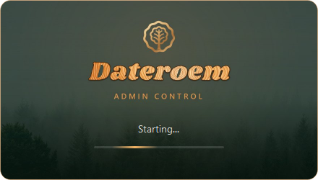
Figure 1: The Starting window, leading into the forest intro

Figure 2: The intro: the misty forest coming out of the mist
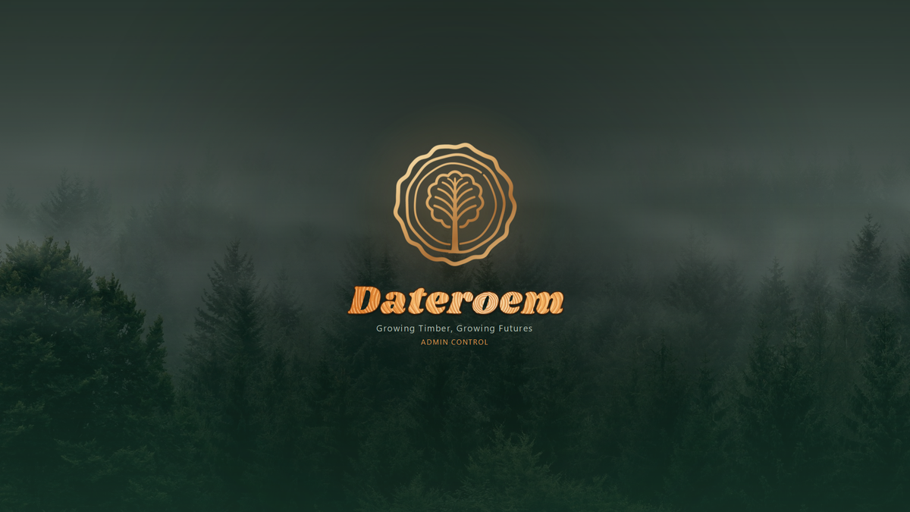
Figure 3: The intro's last picture: the emblem over the misty forest, washed in the app's greens
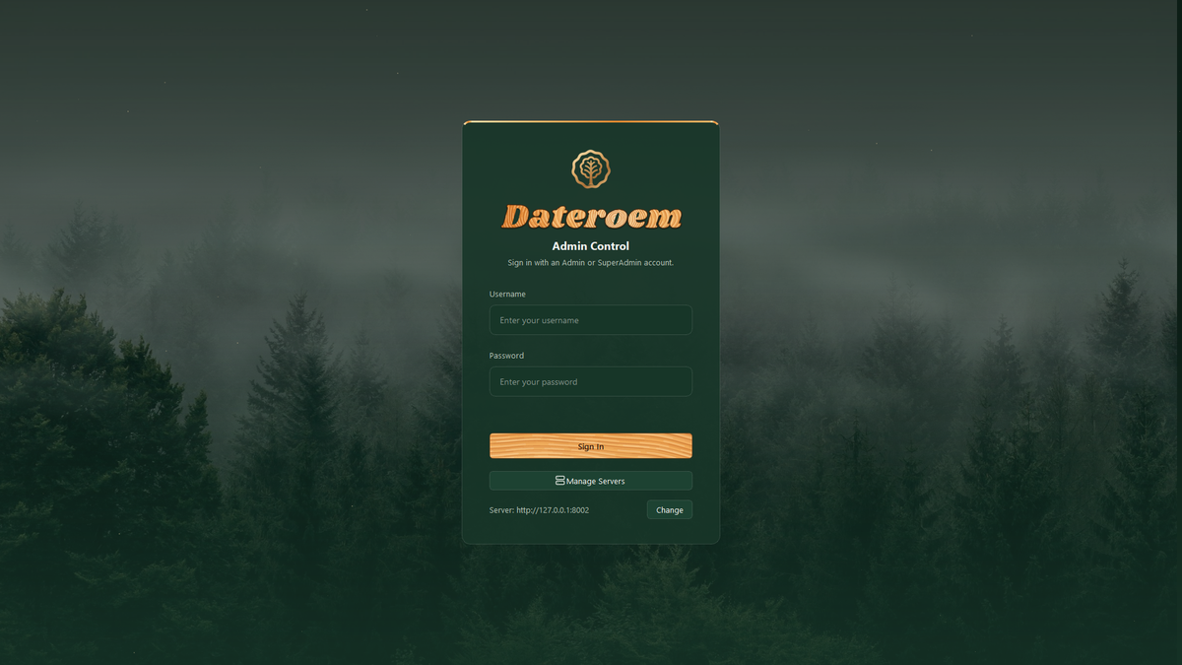
Figure 4: The sign-in window carries on the same forest

3 Sections
Section | What an administrator can do | File (ui/sections)
Dashboard | Quick view of the whole system before drilling in | dashboard_section.py
Insights | Orders (pending groups per customer and area, send to a light or bulk delivery, drop and refund), Unassigned Transactions (assign), Top Farmers, Expense Breakdown, STK Push (send and confirm), Refunds (pay out), Website Payments (every website payment with its M-Pesa receipt, since 17 October 2026); search in the pending groups, unassigned transactions, refunds and payments; the Orders page also shows each order's M-Pesa receipt | insights_section.py, orders_page.py
Products | List with photos and a search box, Deleted toggle, create, edit, delete and restore; the photo is chosen on this computer (see Photos and videos from this computer); Retire and Bring back (retired rows tinted brown); a "Needs attention" banner when products run out of stock, which opens the out-of-stock list | products_section.py
Marketing | Campaigns with one image or video (chosen on this computer) and a search box; create, edit, delete and restore; "Products..." chooses the products a campaign promotes; "Bulk order pictures..." keeps the website's Bulk Orders slideshow | marketing_section.py, campaign_products_dialog.py, showcase_dialog.py
Ratings | Every customer review with its author, searchable; hide or show | reviews_section.py
FAQs | The questions on the website's Help page: add, edit (topic, question, answer, a button to a page, order, shown or hidden), delete and restore; searchable | faqs_section.py
Trips & Finance | Trip list (searchable) and creation; each trip opens a window with tabs: Summary, Loans, Capital, Deliveries, Expenses, Trees, Machinery, Vehicles; Finalize trip. Trees and expense entries can be searched. | trips_section.py, trip_detail_dialog.py, expenses_tab.py, trip_finalize_dialog.py, loan_detail_dialog.py
Delivery Areas | Pickup and delivery points, searchable; city chosen from Kenya's 47 counties; coordinates, with areas missing them highlighted | delivery_areas_section.py
Users | Normal Users: search and role filter, disabled accounts kept under "Show disabled" (activated again there); create staff accounts with any role except SuperAdmin, edit, enable or disable, choose the one account that may sync company SMS. Farmers (searchable). Phones and Computers: the phone each account uses the mobile app on, and the computer each Admin or SuperAdmin uses this app on - only the SuperAdmin approves, replaces, rejects or blocks them. The SuperAdmin can also hand the role over (Make SuperAdmin) and correct an account's username (Edit) | users_section.py
Database Browser | Read-only view of any table, grouped into categories, with a row limit (all, 50 ...) and a search box; password and key columns show (hidden) | database_browser_section.py
Servers | Start and stop each server, Start All and Stop All, live logs - only in the owner's copy and only while the servers run on this computer | ../widgets/server_control_panel.py
Table 1: Desktop sections

4 Signing in from any computer
Since 5 October 2026 the app no longer has to run on the computer the servers run on ("a standalone application that has higher privilege that can work even if the backend is not in the same machine"). It signs in to whatever server address is set, proves which computer it is on, and the backend checks that on every request. This is what lets the servers move to a hosting provider and the app be given to other admins.

4.1 The server address
The bottom of the sign-in card shows the server, for example "Server: http://127.0.0.1:8002", with a Change button. Type the new address (for example https://admin.yourdomain.co.ke) and it is kept for this Windows user in %APPDATA%\Dateroem Admin Control\settings.json. Moving the servers to a provider is then a matter of changing this address - no new copy of the app. The copy for other admins starts at the public address instead (see Sharing the app with other admins).
Figure 5: The sign-in screen on the owner's computer: Manage Servers, and the server address with Change
- Plain http:// is accepted only for this computer and the local network; an address on the internet must start with https://, so passwords and data are never sent unencrypted.
- The default is 127.0.0.1 rather than "localhost": Windows tries localhost's IPv6 address first, and that route into WSL can hang until the request times out.
- Product and campaign pictures come from the same server (media/ addresses), so they load wherever the app runs.
- https:// addresses are reached through Windows' own network stack (WinHTTP, core/http.py) with its usual certificate checks. On the office network Python's built-in encrypted connections to the tunnel are cut off during the handshake while Windows' own get through - the same fault that made pip downloads fail on this computer. Plain http:// to this computer or the local network keeps Python's own.

4.2 Approved computers
Each Admin or SuperAdmin account may use the app on one approved computer, the way each account may use the mobile app on one approved phone.
- On its first sign-in the app asks Windows to create this computer's own sign-in key (core/computer_key.py). The computer's TPM security chip holds it where there is one, otherwise Windows' key store; it can never be exported, so copying the app or its folder to another computer does not copy it.
- Every sign-in signs a one-time challenge from the server with that key, alongside the username and password.
- The SuperAdmin's own first computer is approved automatically (nobody else could approve it). Any other computer is told: "This computer is waiting for approval. Ask the SuperAdmin to approve it in the desktop app (Users > Computers), then sign in again." The app adds the name the computer is listed under.
- The SuperAdmin opens Users > Computers, checks the name and approves it. The person signs in again.

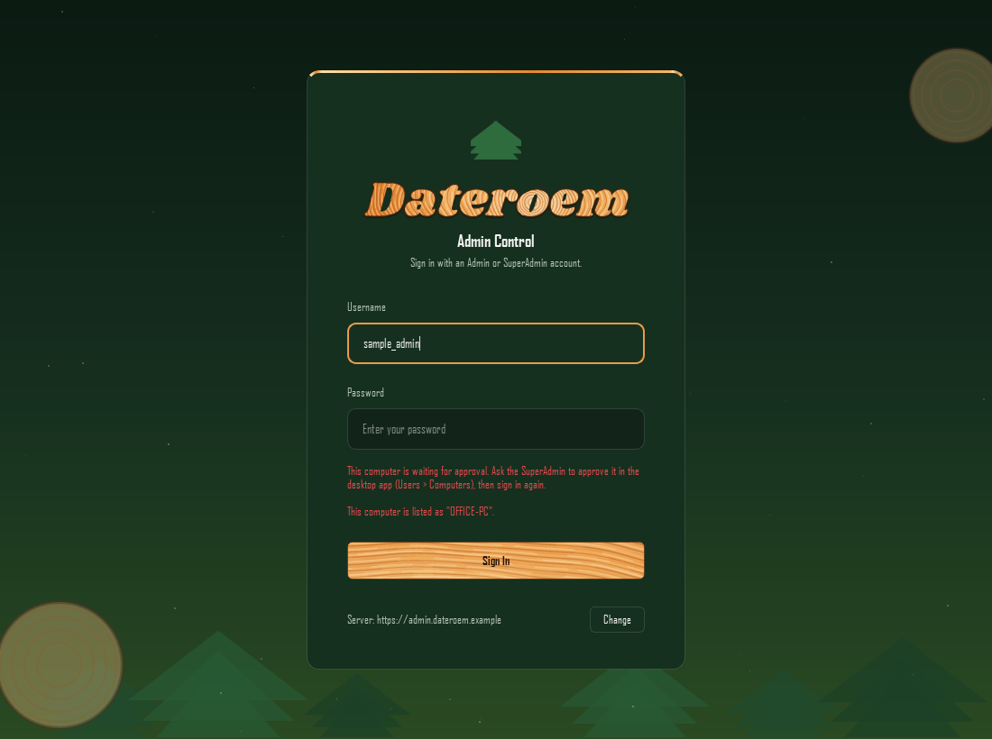
Figure 6: A copy of the app on another computer, pointed at a hosted server, waiting for approval (sample account)
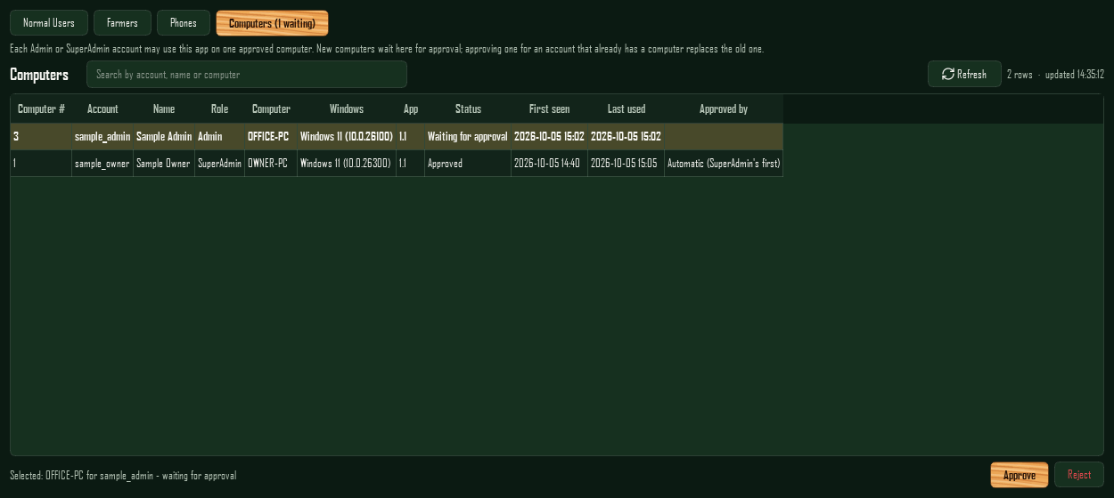
Figure 7: Users > Computers as the SuperAdmin, with a waiting computer selected (made-up sample accounts)
The Computers list works like Phones: waiting rows are tinted and counted on the button ("Computers (1 waiting)"); Approve asks before replacing an account's current computer; Reject or Block stops a computer at once - its next request signs it out. Admins see the list with the buttons greyed out and the note "Only the SuperAdmin can approve or block computers."

4.3 Sign-in rules
Rule | What happens
Who | Admin and SuperAdmin only. Any other role is told "The 'Customer' role can't use the desktop app - Admin or SuperAdmin only." (with its own role name), and its computer is not recorded.
How long | A sign-in lasts 12 hours (a phone's or website's lasts 30 days). After that, or as soon as the computer is blocked, the account disabled or its admin role taken away, every open screen's next request is refused and the app goes back to the sign-in screen with the reason, for example "Please sign in again."
Wrong passwords | Five wrong passwords for one account from one address within 15 minutes: "Too many wrong passwords. Try again in N minutes."
Old copies | A copy without the computer check, or older than the server's lowest accepted version, is told "This copy of the desktop app is too old - please install the new one."
Acting user | Every change is recorded against the signed-in account. The backend takes it from the sign-in, never from what the app sends, so nobody can act as someone else.

Where to adjust: Sign-in length: AUTH_DESKTOP_JWT_EXPIRY_HOURS for the backend (12). Wrong-password limit: MAX_FAILURES and WINDOW_SECONDS in admin_server_control/server/app/core/sign_in_limit.py. Oldest accepted copy: MIN_DESKTOP_VERSION for the admin server (1.1); this copy's own number is APP_VERSION in desktop/app/core/version.py.

4.4 One SuperAdmin
There is exactly one SuperAdmin (today sadmin; since 5 October 2026 the other two former SuperAdmins are Admins with the same access as before). The SuperAdmin is the one account that:
- approves, replaces, rejects and blocks phones (Users > Phones) and computers (Users > Computers);
- can change the SuperAdmin account - Admins see "only the SuperAdmin can change this account" and its Edit button is greyed out. It can't be disabled at all, and no new account can be created as SuperAdmin;
- can correct a username typed wrongly when an account was made: Edit shows a Username field to the SuperAdmin only. The new username follows the sign-up rule (3 to 30 characters, no spaces, no @) and must not be taken; the person then signs in with the new one (their sign-in, phone and computer stay as they were), and the change is written to the audit log;
- can hand the role over: select an active staff account in Users > Normal Users and press Make SuperAdmin. After confirming, that account becomes the SuperAdmin, the giver becomes an Admin in the same step, and the app asks the giver to sign in again.

4.5 Sharing the app with other admins
The copy given to other admins is the same app without core/server_manager.py - that file starts and stops this computer's own servers and holds this computer's tunnel settings - and the two Servers windows that use it. Without them the app simply has no Servers panel and no Manage Servers button. Nothing else in the app is secret: the server address is set on each computer, and access depends on the account and an approved computer.
Since 5 October 2026 it is built with admin_server_control/desktop/build_shared_copy.py, run with the app's own Python: venv\Scripts\python.exe build_shared_copy.py https://<public address>/admin-api. The result is desktop\dist\Dateroem Admin Control 1.1.zip (about 42 MB): a Windows app folder with Python inside, so nothing has to be installed. The address given is written into app/core/default_server.txt inside the copy and is where it starts; the script stops if any owner-only code got into the build. The first copy starts at the public tunnel address, /admin-api.
- Give the admin the zip (email, USB stick or a shared folder).
- They unzip it anywhere (for example into Documents) and open Dateroem Admin Control.exe in the folder. The app is not code-signed, so Windows may say "Windows protected your PC": More info, then Run anyway.
- They sign in with their Admin account. The screen says the computer is waiting for approval and gives the name it is listed under.
- The SuperAdmin approves that computer in Users > Computers, and they sign in again.

Note: Only one copy of the app runs at a time on a computer, whichever copy it is. When the servers move to a provider, each copy keeps working once its address is changed with Change - or rebuild the zip with the new address for new admins.
Security: If a computer with the app is lost, stolen or given away, block it in Users > Computers at once. Its key stays on that computer, but a blocked computer can no longer sign in.

5 Working in the app

5.1 Money actions
Every payout (Send Money for an expense, Pay Loan, refund) opens widgets/payout_dialog.py: the details are shown in bold for a final check, then a green transfer animation (widgets/transfer_scene.py) follows the payment until M-Pesa confirms it or reports why it failed. Refunds pre-fill the customer's phone number.

5.2 Approving phones
Since 3 October 2026 each account may use the mobile app on one approved phone (see the Backend Server document, Approved phones). An account's first phone is approved automatically; any other phone that signs in waits here, and since 5 October 2026 only the SuperAdmin can approve or block it (Admins see the list with the buttons greyed out). Open Users and choose the third button, Phones. Its label shows how many phones are waiting, for example "Phones (2 waiting)", and waiting rows are tinted amber.
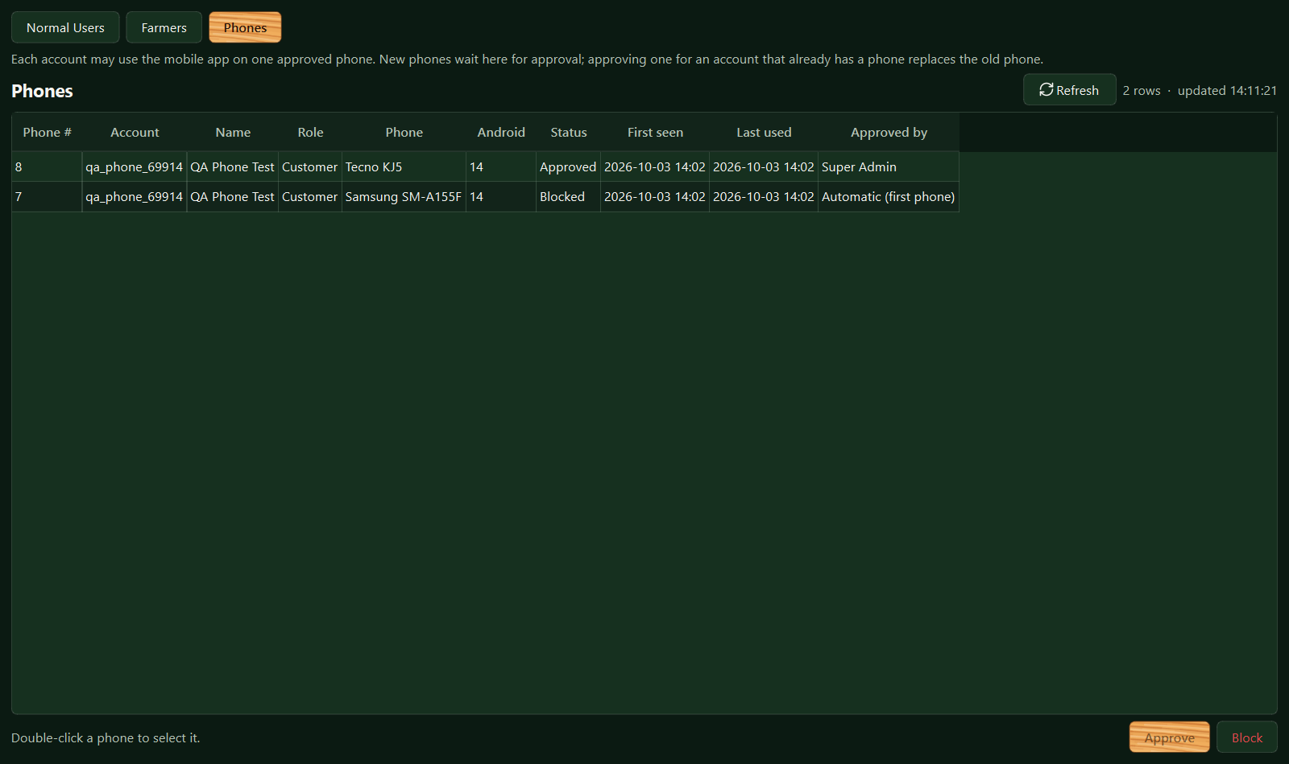
Figure 8: Users > Phones (test data): the newer phone was approved with replace, so the older one shows as Blocked
Column | Meaning
Phone # | The phone's number in USER_DEVICES
Account, Name, Role | Who signed in on it
Phone, Android | The phone model and Android version the app reported
Status | Waiting for approval, Approved or Blocked
First seen, Last used | When it first signed in and when it was last used (updated at most once a minute)
Approved by | The SuperAdmin (or, before 5 October 2026, the admin) who approved it, or "Automatic (first phone)"

Double-click a phone to select it, then:
- Approve - for a waiting or blocked phone. If the account already has an approved phone, the app names that phone and asks before replacing it; replacing blocks the old phone in the same step. The person then taps "Check again" on the new phone.
- Reject (waiting phone) or Block (approved phone) - the phone can no longer be used for that account. An approved phone is cut off on its very next request. A blocked phone can be approved again later.

Tip: When someone replaces or loses a phone, or reinstalls the app, the new install appears here as waiting. Check with the person that the phone model matches before approving with replace. If a phone is lost or stolen, block it here at once.

5.3 Help page questions (FAQs)
Since 7 October 2026 the FAQs section keeps the questions on the website's Help page - "so that it constantly maintained based on changes done on certain features". When a feature changes, update its answer here; the website shows the change at once. New Question and Edit open a form with the topic, the question, the answer (several lines; lines starting "1. " show as numbered steps), an optional button to a page of the website, the order (smaller shows first; a new question goes last) and Show on the website - untick it to take a question off for a while without deleting it. Delete moves it to Show deleted, where Restore brings it back. Every change is in the audit log.
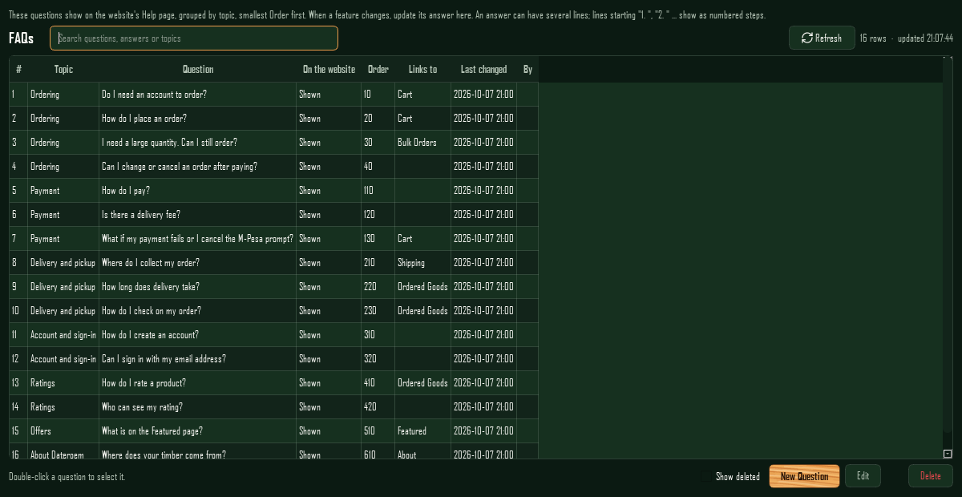
Figure 9: The FAQs section with the first questions

5.4 Finding things: search and filters
Long lists have a search box above them (added 3 October 2026). Typing narrows the list at once to the rows where any visible column contains what was typed (capital letters do not matter); phone numbers match in any form (0712..., 712... or 254712...). If the list is limited by "Show" (for example 50 rows), typing switches it to All first, so nothing beyond the first rows is missed. The count line shows how many rows match ("Showing 5 of 60").
Where | Searches
Users > Normal Users | Name, username, phone (any form) and email, plus a Role filter whose list shows how many accounts have each role ("Customer (48)"). Every account is loaded, filtered on the computer, and then the Show limit is applied.
Users > Farmers, Users > Phones | Farmers by name or phone; phones by account, name or phone model
Products, Marketing, Ratings, Delivery Areas | Products by name, type or SKU; campaigns by name, channel or status; ratings by product, customer or comment; areas by town or area name
Insights | Pending orders by customer, phone or area; unassigned transactions by receipt, phone or amount; refunds by customer or phone
Trips & Finance | Trips; inside a trip, its trees (by farmer or type) and each expense category's entries
Database Browser | The rows loaded from the chosen table

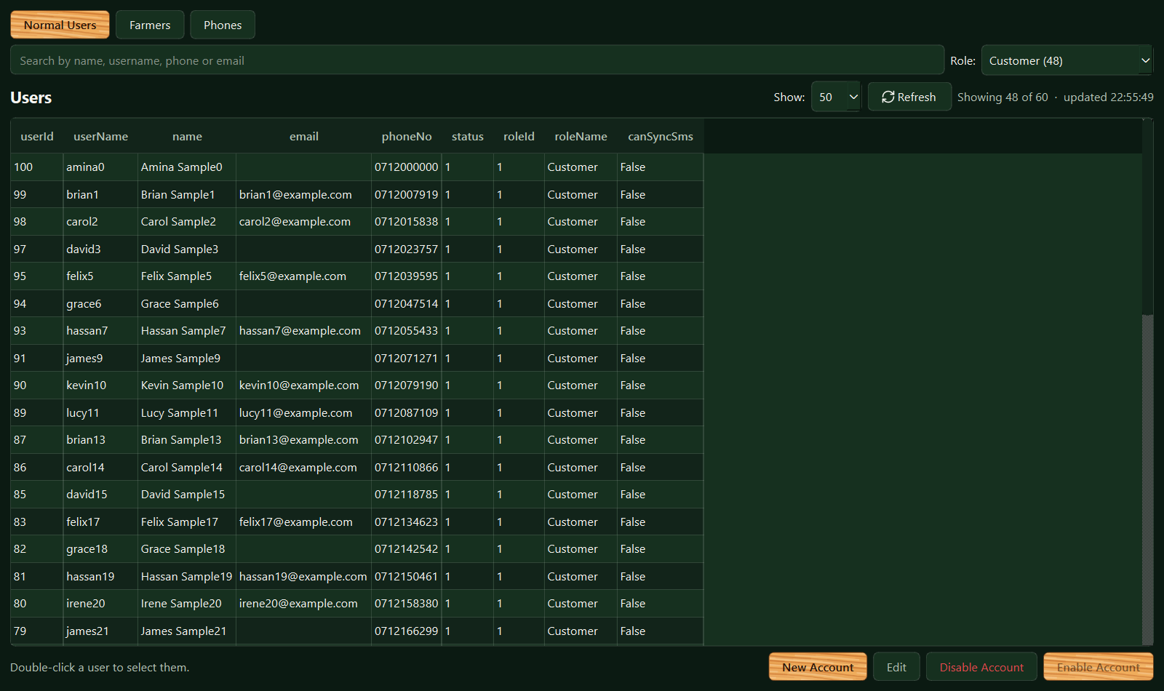
Figure 10: Users > Normal Users with the search box and the Role filter (made-up sample accounts)
Note: A list shows what was loaded when the section opened. Someone who signs up on the website while the desktop app is open (for example with Google) appears after pressing Refresh.

5.5 Products in a campaign
The website shows a campaign only while it is Active, within its dates and promoting at least one product (see the Website User Interface document, Featured campaigns). Choose a campaign in Marketing and press Products...: a window lists every product with a search box; tick the ones the campaign promotes and press Save. Saving replaces the campaign's whole set at once; products in the bin keep their links. After New Campaign the app offers to open this window straight away ("Choose the products ... promotes now?").
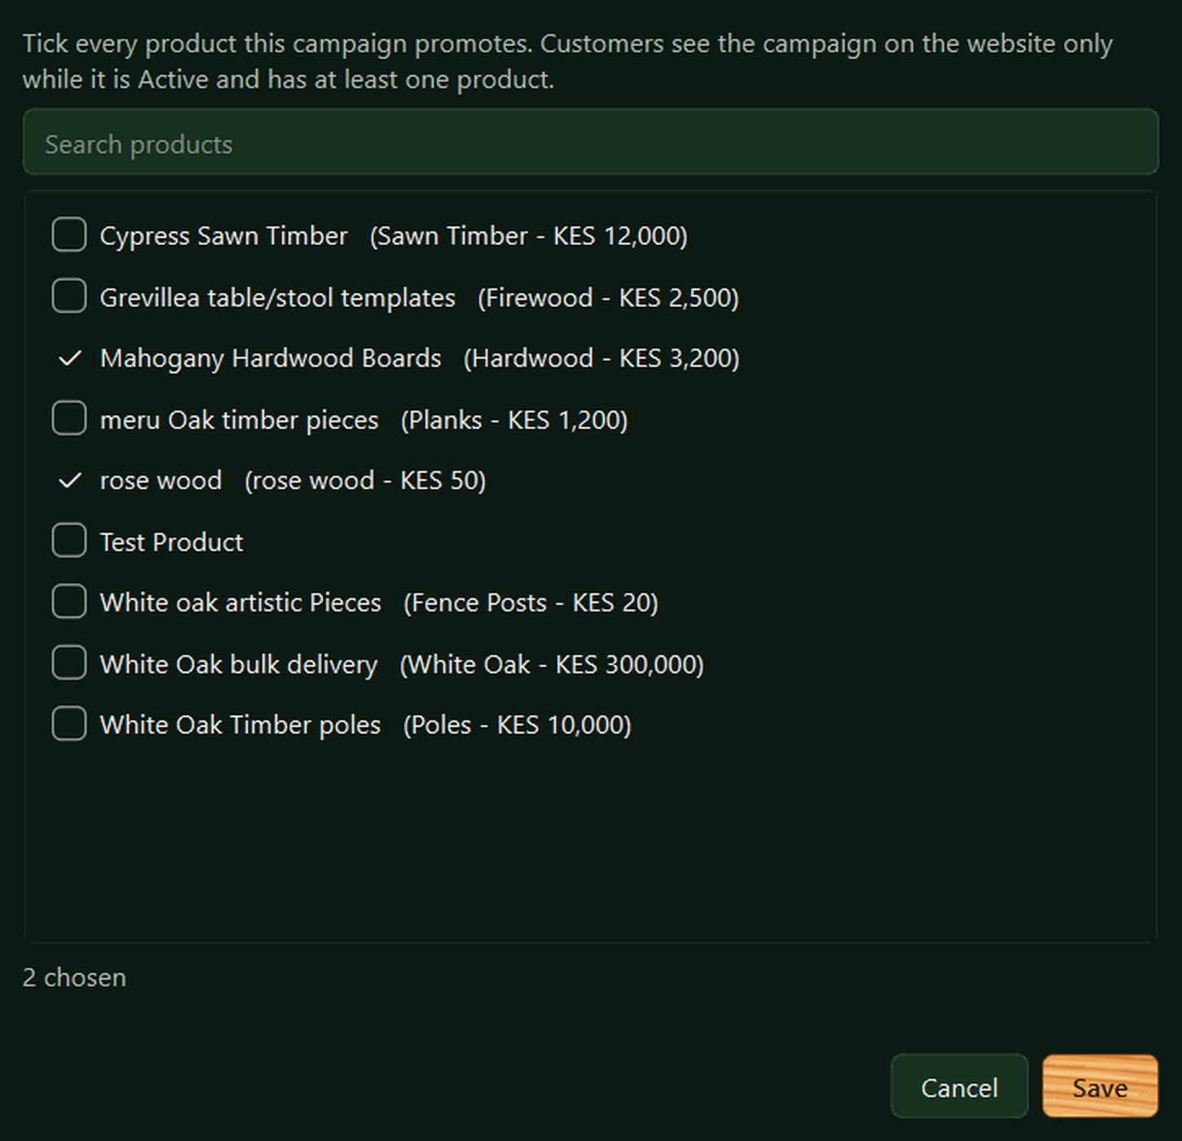
Figure 11: The Products window of a campaign (Marketing > Products...)

5.6 Bulk order pictures
Since 9 October 2026 the website's Bulk Orders page plays example photos of real bulk orders so customers can see what is meant (see the Website User Interface document). In Marketing, Bulk order pictures... opens the window that keeps them; Marketers (from the phone app), Admins and the SuperAdmin may change them, and every change shows on the website straight away.
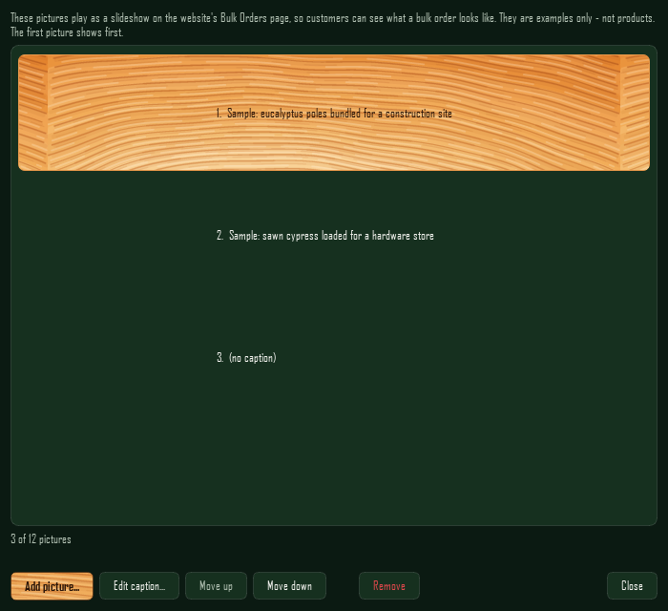
Figure 12: Marketing > Bulk order pictures... (sample pictures)
- Add picture... - choose a photo (JPEG, PNG, WebP or BMP), see it, give it an optional caption (up to 120 characters, with a counter) and press Add picture. The app shrinks it to at most 1600 pixels as a JPEG before sending (the admin server has no image library), and it goes at the end of the slideshow. Up to 12 pictures; at 12 the button switches off until one is removed.
- Edit caption... (or a double-click), Move up and Move down act on the highlighted picture; the list numbers them in the order they play. If someone else changed the pictures meanwhile, the move is refused and the list shows them as they are now.
- Remove asks first; the picture leaves the slideshow at once (the record is kept, marked removed).
- Each picture is shown whole on a dark card, as the website shows it, so upright phone photos are not cut off.

5.7 Order tickets and sharing the driver
Since 23 October 2026 every order has a ticket like DW-7K3Q9P (migration 038) - the code the customer sees and quotes. Insights > Orders shows it in a Ticket column and a tickets column per customer (the search finds a group by ticket), the assign and drop windows name orders by it, and Refunds, Website Payments and the trip's deliveries show it too.
Customers no longer see the driver or the vehicle by default. When assigning a group to a new delivery, tick Share the driver's first name and the number plate with the customer; orders added to an existing delivery follow that delivery (the box shows its choice and can't be changed there). In a trip's Deliveries tab, select a light delivery and use Share Driver / Stop Sharing Driver - it asks first and applies to every order on that delivery. The customer then sees the driver's first name, the number plate and the company phone, never the driver's own number.
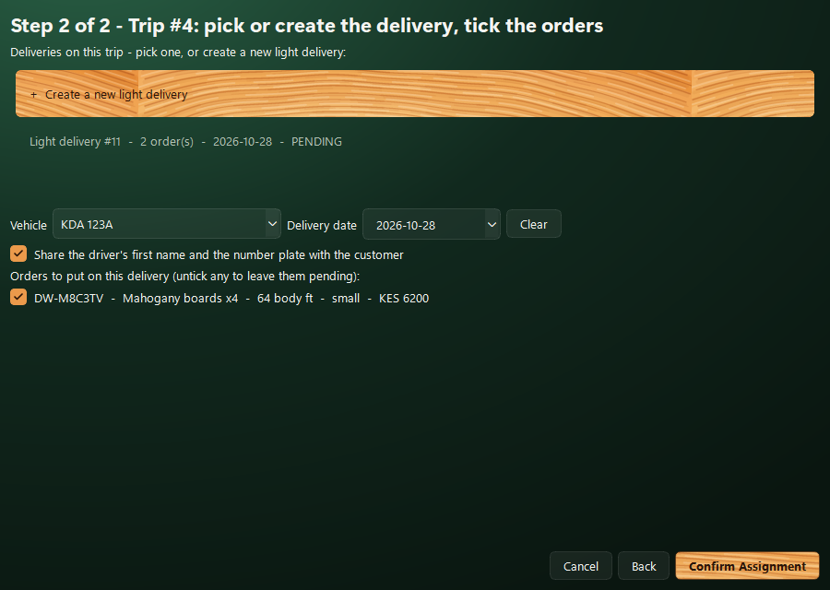
Figure 13: Assigning a group to a new delivery with the driver shared (made-up orders)
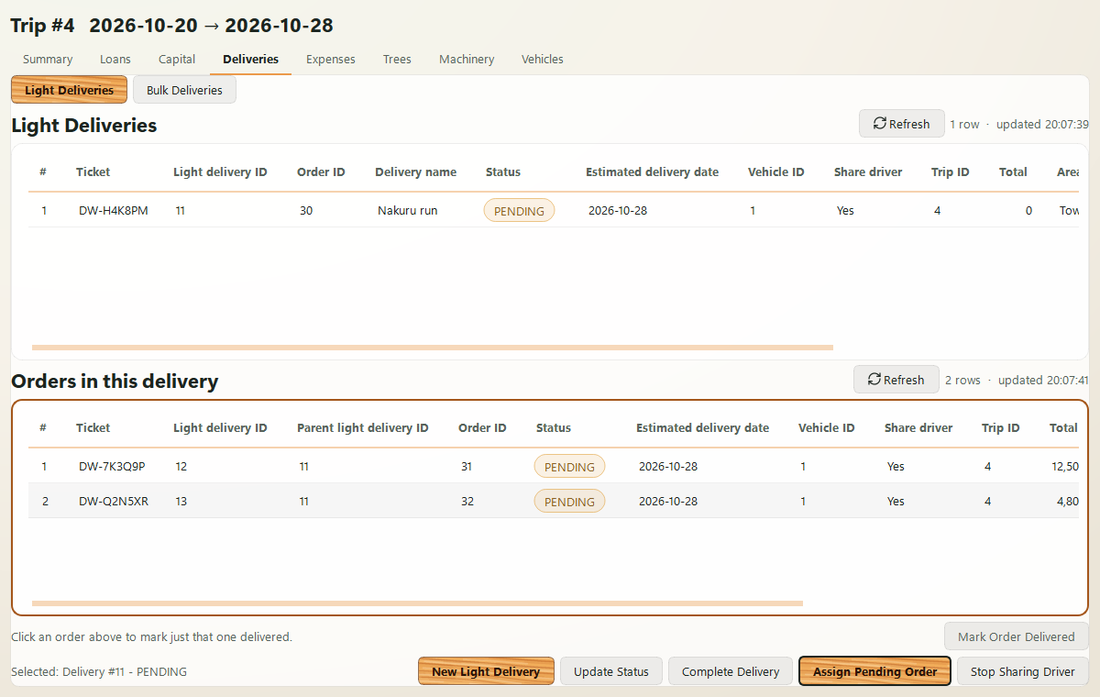
Figure 14: A trip's light deliveries with the Ticket and Share driver columns (made-up orders, Light theme)

5.8 Website payments and M-Pesa receipts
Since 17 October 2026 "i need to see this": Insights, Website Payments lists every payment made on the website, newest first - date, M-Pesa receipt, order, customer, amount, the payment's and the order's status, and a note (why a payment failed, or that Safaricom confirmed it without sending a receipt number). Search by receipt, customer or order number; double-click a row to copy its receipt. The Orders page shows the same receipt beside each order.
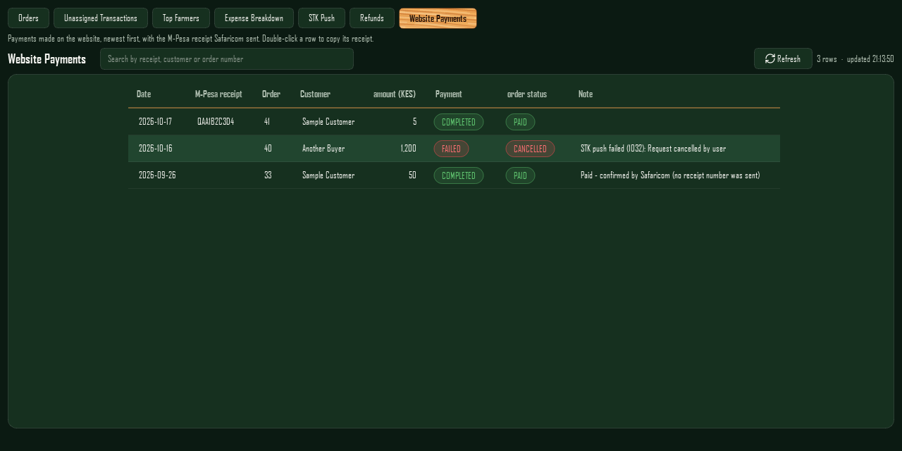
Figure 15: Insights > Website Payments (sample data)

5.9 Photos and videos from this computer
Since 10 October 2026 "the ability to go to media and pick a new media ... since i can be having the video or photo here in the laptop": the product form has a Photo field and the campaign form a Photo or video field, chosen from this computer the way Bulk order pictures are. Before, the forms asked for a typed media key.
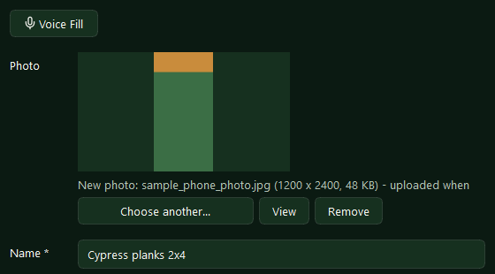
Figure 16: New Product with a photo chosen on this computer (sample photo)
- Choose from this computer... opens the usual Windows file window: photos (JPEG, PNG, WebP, BMP) for a product; photos or videos (mp4, mov, webm, 3gp, m4v) for a campaign. The field shows the photo (whole, on a small card) or, for a video, its name and size, with "uploaded when you save".
- A photo is turned the right way up (phones often store the turn separately), shrunk to at most 1600 px and saved as JPEG on this computer before sending - the same size as a photo taken in the phone app. A video is sent as it is; over 60 MB is refused before anything is sent ("Video too large"). A product refuses a video ("Photos only").
- Nothing is sent until Save. Then the file goes up first (named after the product or campaign, through the admin server's /uploads/products or /uploads/campaigns) and the record is saved with the key it gets; a campaign's media type (IMAGE or VIDEO) comes from the file, so there is nothing to pick by hand. If the save is refused (a missing price, say), the form stays open and pressing Save again does not upload the file a second time.
- Editing: the current photo or video is named (and a photo shown); Replace from this computer... swaps it, View opens it in the computer's own viewer, and Remove takes it off on Save. Saving without choosing anything keeps what is there.
- Long forms scroll inside the window when the screen is too short for them.

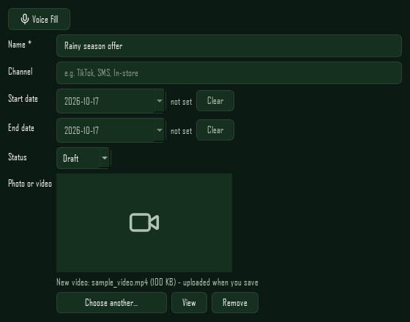
Figure 17: New Campaign with a video chosen on this computer (sample file)
Where to adjust: Limits and file types: app/ui/widgets/media_picker.py (MAX_SIDE, JPEG_QUALITY, VIDEO_EXTENSIONS, MAX_VIDEO_BYTES) and, on the server, admin_server_control/server/app/routers/uploads.py (keep them the same). The fields themselves: _fields() in products_section.py and marketing_section.py. The Bulk order pictures window reads photos with the same load_photo, so phone photos are upright there too.

5.10 Tables
"the display of the tables in the old rectangles feels so outdated" - since 17 October 2026 every list is drawn the same modern way (ui/widgets/data_table.py, styles in ui/theme.py):
- Each table sits in a rounded card with space from the edge; no grid lines, roomy rows, a deeper stripe on every other row and the app's own wood-coloured scrollbars.
- A table whose columns fit keeps its own width and sits in the middle of the card; a wide one fills the card and scrolls sideways.
- Status-like columns show coloured pills (green active or done, amber waiting, red stopped or failed, blue for roles); money is right-aligned with thousands separators; column titles read as words (Product ID, Marketer note).
- Long text (a description) wraps in a column at most 300 pixels wide and shows the first 140 characters; the whole text is in the tooltip. Columns empty in every row are left out. A campaign video shows a video mark.
- Users: disabled accounts leave the main list and appear under "Show disabled (N)", where "Activate Account" brings them back. A "Phone verified at" column appears once customers confirm their numbers by SMS code.

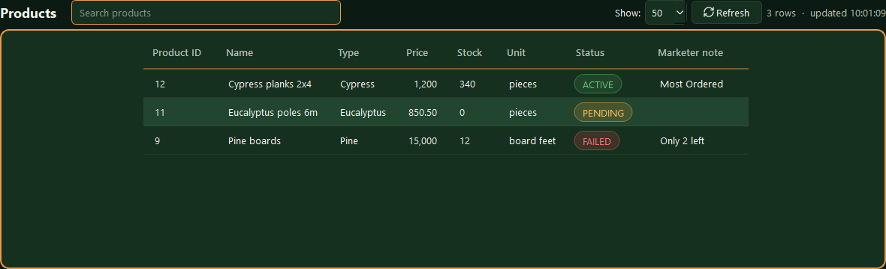
Figure 18: A product list (sample data)
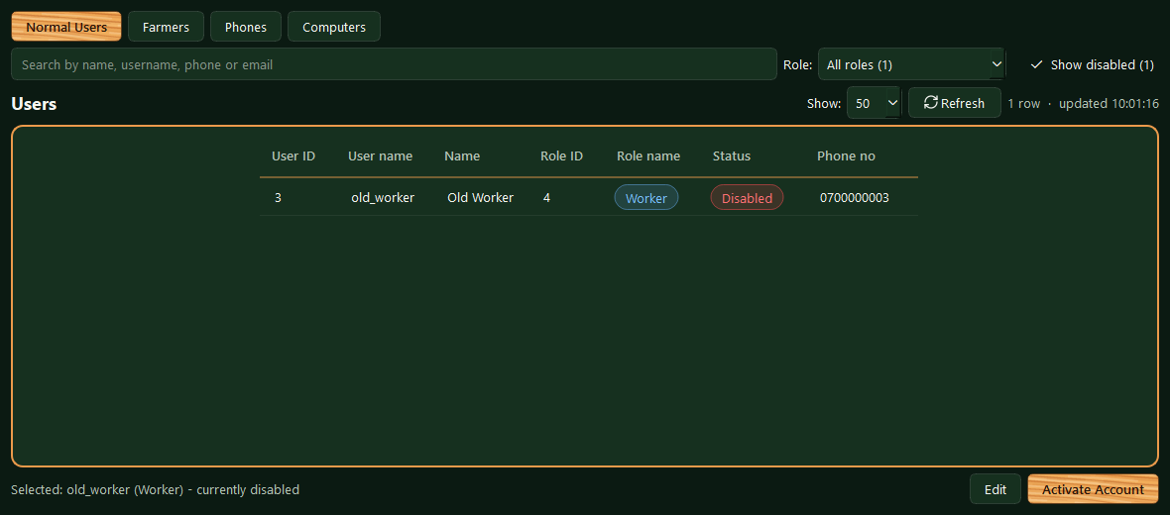
Figure 19: Users, Show disabled (sample account)
Where to adjust: Colours: TABLE_ALT, ROW_LINE and the STATUS_ colours in ui/theme.py. Sizes: LONG_TEXT_CHARS, LONG_COLUMN_WIDTH, LONG_TEXT_PREVIEW, CARD_MARGIN_LEFT and CARD_MARGIN_RIGHT in ui/widgets/data_table.py.

5.11 Shared widgets
Widget (ui/widgets) | Purpose
data_table.py | Tables (see Tables) with a row limit selector, an optional search box (searchable=True, search_placeholder=), product photos where a row has an image (loaded from the server's media/ addresses and kept in memory once loaded), notes in empty cells, and a refresh button whose arrows spin while loading
record_form_dialog.py | One create/edit form used by most sections; its fields scroll on a short screen, and a photo or video field (type "media") uploads its file on Save
media_picker.py | Photo or video chosen on this computer for the product and campaign forms (since 10 October 2026)
date_picker.py, image_picker.py | Calendar date entry and photo selection (scaled down before upload)
busy.py | The shared "working..." state for action buttons
server_control_panel.py | The Servers section (next chapter)

Forms can also be filled by voice using Windows' built-in speech recognition (core/voice_input.py, no API key needed). All icons are line icons from ui/icons.py (a tree-ring cross-section for Products) and the colours match the website and mobile app (ui/theme.py). Since 20 October 2026 these are the board's "Living Forest" greens (BACKGROUND #0f241b, SURFACE #1d4232, SURFACE_ALT #173628, table stripe TABLE_ALT #295a45), chosen because the older green felt "too lazy and not lively".
Colour themes (since 20 October 2026): Settings, a button above Sign Out (ui/settings_dialog.py), offers Forest, Dark and Light as small previews. Picking one saves it with the account (PUT /auth/me/theme) - the website and the phone app open in it too - and theme.set_theme() swaps the colours and rebuilds the stylesheet; the main window is then built again in the new colours and faded in over the old one, on the same section and without signing in again (restyle_main_window in main.py). Icons without a colour of their own take the theme's text colour (ui/icons.py). The theme comes with the sign-in; the sign-in screen itself always shows the forest. A desktop that is already open is not changed by a choice made on another device until someone signs in again.
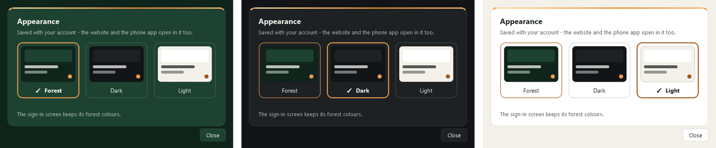
Figure 20: Settings - Appearance in Forest, Dark and Light
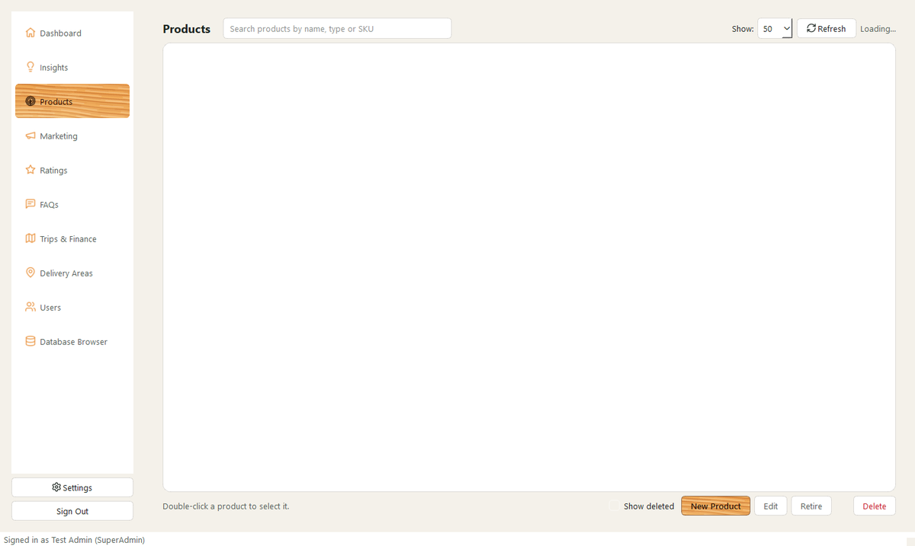
Figure 21: The main window in the Light theme (a made-up admin, no server connected)
The modern look (since 21 October 2026: "the green doesn't feel like one color ... make it look modern"). The main window stands on a painted backdrop instead of a flat colour (ui/backdrop.py): a glow in the top-left corner fading into the theme's darkest shade, with a fine grain - green in Forest, layered charcoal in Dark, warm paper in Light - drawn once per window size. The menu floats on it without a panel, 188 px wide (it was 210), with a soft pill and a short wood bar on the chosen section; the menu button above it folds the menu to its icons (62 px, names on hover), remembered on the computer. In Dark the menu sits on a pane of dark glass with still raindrops (no animation). Tables and panels stand on slightly see-through rounded cards; titles use Windows 11's own font; tabs are underlined in wood. Pop-up windows - forms, payments, trip, loan and order windows, Bulk order pictures, Settings - carry the same depth as one gradient (DIALOG_BACKDROP), and tick boxes are drawn as rounded boxes that fill with wood and a dark tick, clear in every theme. Colours are read when a window opens, never once at start-up: the Bulk order pictures list used to keep the Forest green in Light and Dark (fixed 21 October 2026). The whole look is set in theme.build_modern_stylesheet(); DATEROEM_MODERN_UI=0 brings back the earlier flat look.
Dashboard (21 October 2026): each figure carries a short breakdown - Users: customers and staff, staff by role, disabled accounts; Products: in the shop, retired, deleted, out of stock; Campaigns: running now, upcoming and ended, photos and videos, deleted; Trips: in progress and finished, deliveries made. The Database tables figure is shown to the SuperAdmin only.
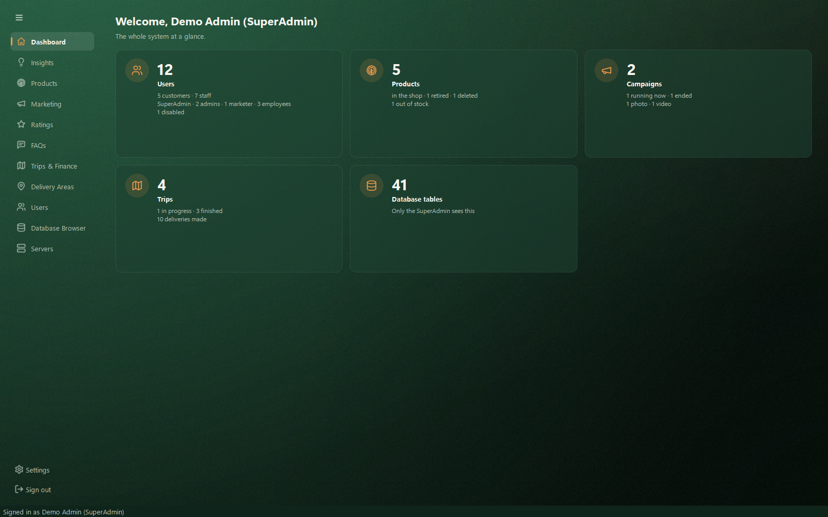
Figure 22: The dashboard in the modern look (Forest; demo figures)
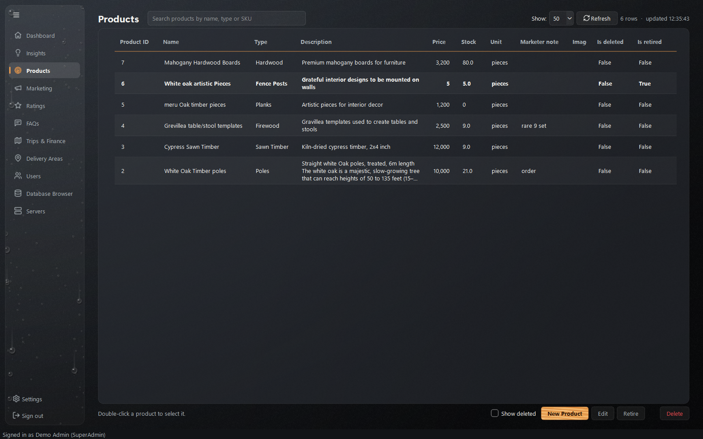
Figure 23: Products in the Dark theme, with rain on glass behind the menu (demo data)
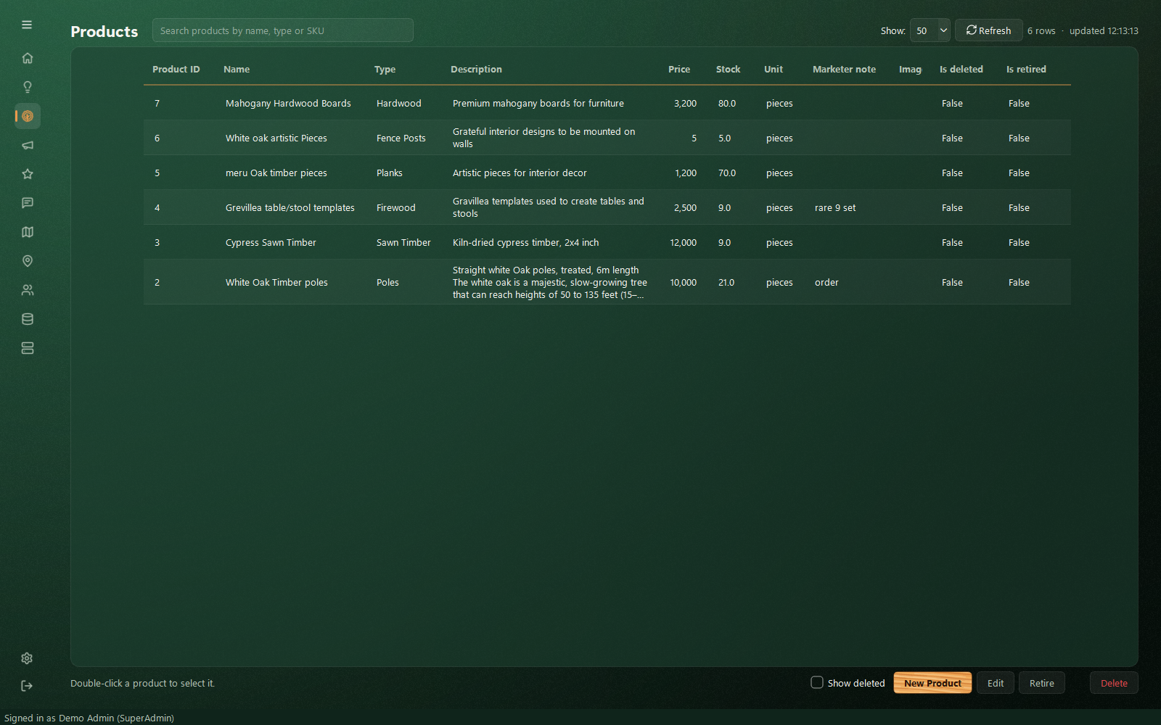
Figure 24: The menu folded to its icons, giving the table the full width
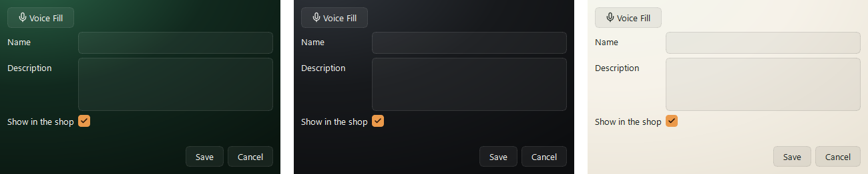
Figure 25: Pop-up windows in the modern look: Forest, Dark and Light (demo data)

6 Servers panel
The Servers section starts and stops every part of the system without opening terminals. It works before sign-in and does not need any server to be running. It appears only in the owner's copy of the app (the one with core/server_manager.py) and only while the server address is this computer (127.0.0.1 or localhost) - starting and stopping only works where the servers run.
Since 7 October 2026 anyone can start servers - before signing in, or signed in as any admin - so an honest admin can always bring the system back. Only someone signed in as the SuperAdmin can stop them (Stop and Stop All), after confirming; for everyone else the two buttons are greyed out and the panel says why. On the sign-in screen, Manage Servers swaps the two cards (since 20 October 2026): the sign-in card shrinks back and dissolves into a cloud of mist that spreads into the forest, then a second mist comes forward and the servers card takes shape inside it, in the middle of the screen, in the misty forest's soft grey-green with the app's wood accents. Back to sign in, Esc or a click beside the card plays it in reverse, and the servers keep running; the two cards never share the screen. (It used to open a separate window, which Windows minimised into a small bar in the bottom-left corner of the screen; on 19 October 2026 it became a panel sliding in from the right.) Opened there it can only start servers, since nobody is signed in.
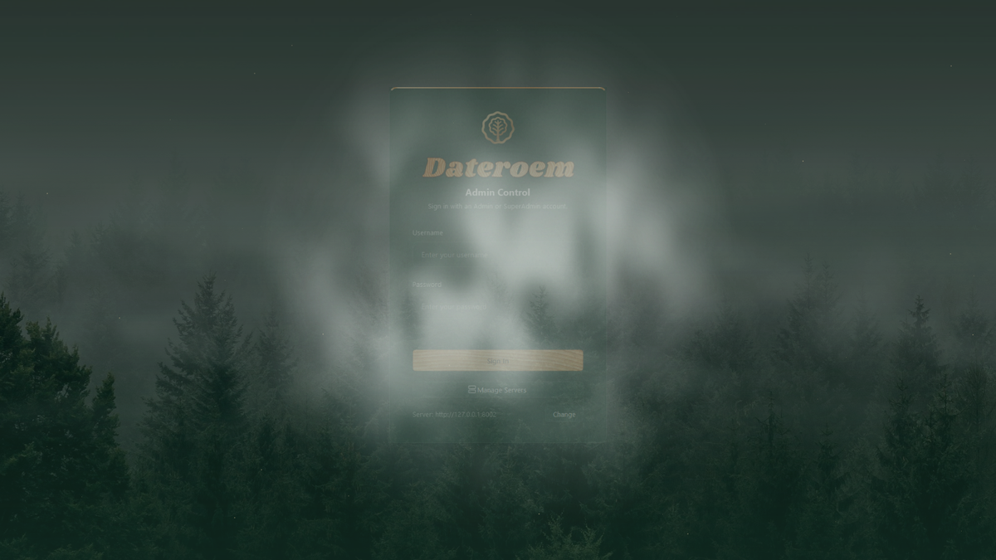
Figure 26: Manage Servers: the sign-in card dissolving into the mist
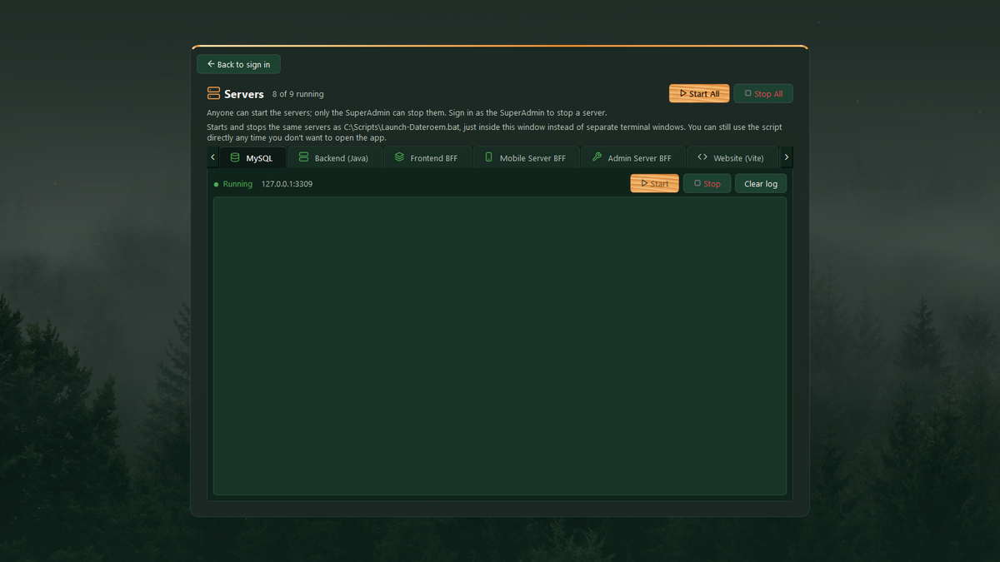
Figure 27: The servers card in the middle of the sign-in screen
Caution: Servers started from the desktop app run inside it: closing the app on this computer also stops them. Leave the app open (minimised) on the owner's computer. Running the servers as Windows background services, which start with Windows and restart themselves, would remove this - and is how they will run at a hosting provider.
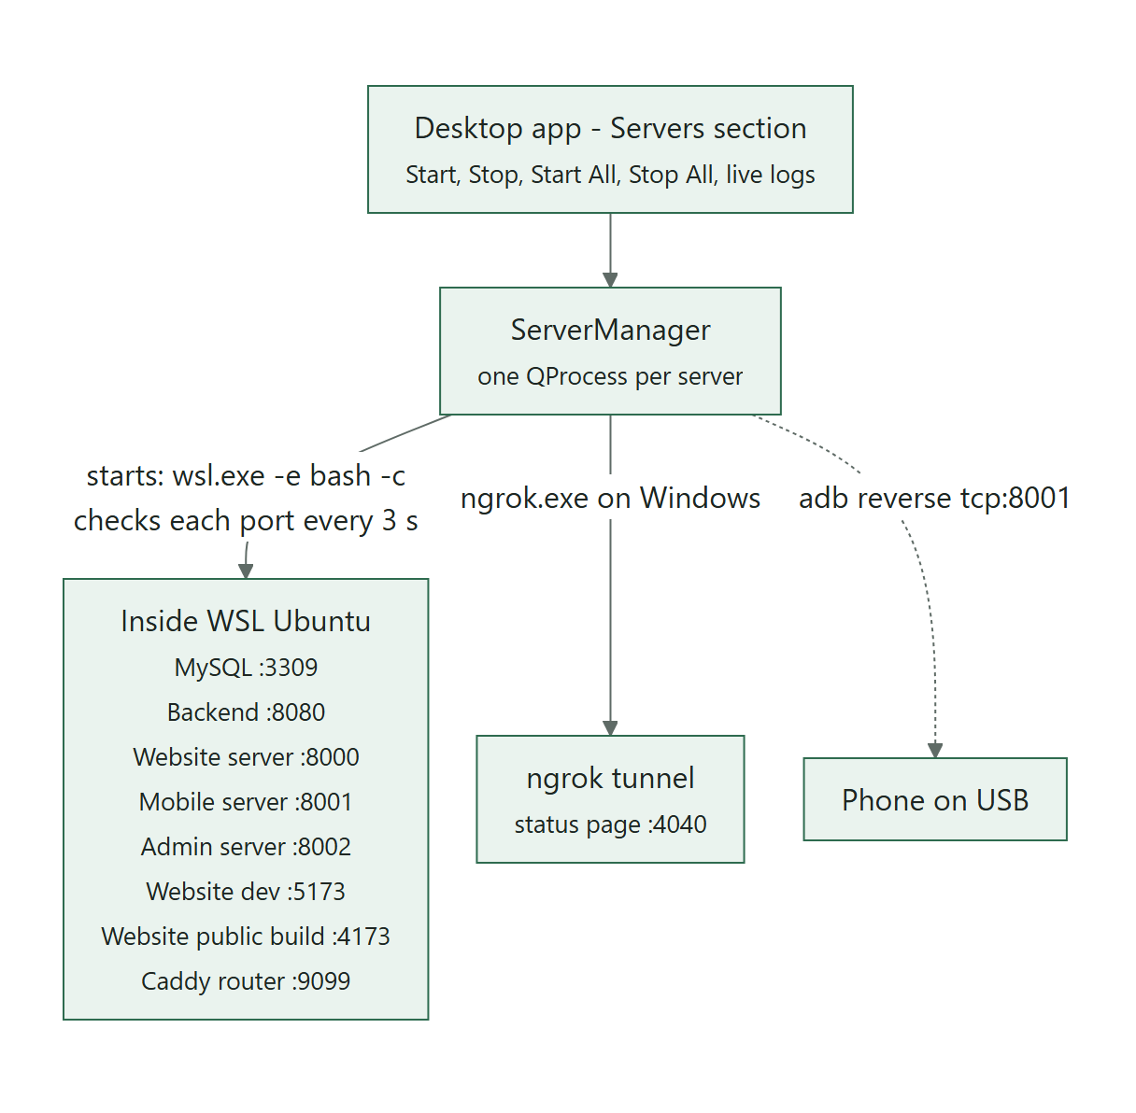
Figure 28: How the desktop app controls the servers
Server | Port | Start command (inside WSL unless noted)
MySQL | 3309 | service mysql start
Backend (Java) | 8080 | cd backend && export <secrets> && mvn spring-boot:run
Frontend BFF | 8000 | cd frontend && venv/bin/uvicorn app.main:app --host 0.0.0.0 --port 8000 --reload
Mobile Server BFF | 8001 | cd mobileServer && venv/bin/uvicorn app.main:app ... --port 8001 --reload
Admin Server BFF | 8002 | cd admin_server_control/server && venv/bin/uvicorn app.main:app ... --port 8002 --reload
Website (Vite) | 5173 | cd frontend/website && npm run dev
Website (public build) | 4173 | cd frontend/website && npm run build && npx vite preview --port 4173
Tunnel Router (Caddy) | 9099 | caddy run --config /root/fathersProject/Caddyfile
Public Tunnel (ngrok) | 4040 | ngrok.exe on Windows: http with the reserved domain, forwarding to 9099
Table 2: Servers controlled by the panel (core/server_manager.py SERVER_DEFS)
- Status comes from a real check of each port every 3 seconds (every second while something is starting or stopping), so servers started outside the app also show correctly.
- Each server shows its state with a coloured dot: starting (with seconds elapsed), running, stopping, stopped or failed ("Try again"). Start All and Stop All show progress and a final message.
- A start counts as failed after 120 seconds (300 for the backend, 240 for the public website build). A stop is given 30 seconds.
- Passwords and keys in the commands are replaced by *** in the on-screen logs.
- When a phone is connected by USB, the panel re-applies adb reverse tcp:8001 tcp:8001.

Security: core/server_manager.py contains the backend secrets in plain text (it mirrors C:\Scripts\Launch-Dateroem.bat). Keep the project folder private, and see the Configuration and Secrets Reference for moving secrets into one protected file.
Where to adjust: Server list, commands, ports and time limits: SERVER_DEFS, START_GRACE_S, SLOW_START_GRACE_S and STOP_GRACE_S in admin_server_control/desktop/app/core/server_manager.py. When a secret changes, update it here and in the launch scripts.

7 Source layout
Path | Contents
desktop/launch.pyw | Entry point used by the shortcut
desktop/build_shared_copy.py | Builds the zip given to other admins (PyInstaller, without the owner-only files)
admin_server_control/desktop/app/main.py | Builds the app: splash, sign-in, main window, shared server manager (when core/server_manager.py is present); goes back to sign-in when a sign-in ends
admin_server_control/desktop/app/core/api_client.py | Calls the admin server at the set address (adds the token and acting user id); signs in with this computer's proof; reports a sign-in that has ended
admin_server_control/desktop/app/core/server_address.py | The server address setting (settings.json, else default_server.txt in a shared copy), its checks, and turning media/ paths into full addresses
admin_server_control/desktop/app/core/http.py | The one HTTP session every call uses; https:// through Windows' WinHTTP
admin_server_control/desktop/app/core/computer_key.py | This computer's sign-in key in Windows (TPM where there is one) and the signed proof
admin_server_control/desktop/app/core/version.py | APP_VERSION, sent with every sign-in
admin_server_control/desktop/app/core/server_manager.py | Server definitions, start/stop, port checks, log masking (owner's copy only - leave it out of copies for other admins)
admin_server_control/desktop/app/core/session.py, worker.py | Signed-in user; running calls off the screen thread
admin_server_control/desktop/app/core/single_instance.py, windows_app_id.py | One running copy; own taskbar identity
admin_server_control/desktop/app/core/voice_input.py | Windows speech recognition for forms
admin_server_control/desktop/app/ui/ | main_window, login_window, splash_screen, entrance_paint (the entrance pictures, shared by the intro and the sign-in backdrop), theme, icons, forest_paint, sections/, widgets/, assets/brand (the emblem, from the website's brand:export), assets/entrance (the entrance photos)

8 Installing and running
- Python for Windows is required. The virtual environment is in \\wsl.localhost\Ubuntu\root\fathersProject\admin_server_control\desktop\venv.
- Install the requirements: venv\Scripts\python.exe -m pip install -r requirements.txt (on this computer PySide6-Essentials and pywin32 were installed from downloaded wheel files because pip downloads kept failing).
- Run venv\Scripts\pythonw.exe launch.pyw, or use the Start Menu shortcut.
- Sign in with an Admin or SuperAdmin account. On any computer other than the SuperAdmin's first one, the SuperAdmin approves the computer first (Users > Computers).
- To use servers on another computer or at a hosting provider, press Change under the sign-in card and enter that address.

9 Development history
Date | Change
2026-09-13 | Desktop administration application started.
2026-09-14 | Full-screen splash, single running copy, taskbar tree icon, forest login, sections mirroring the mobile app, database browser.
2026-09-16 | Servers section: start and stop every server from inside the app with live logs.
2026-09-17 | Database browser grouped into categories.
2026-09-19 | Light and bulk deliveries per trip, date pickers, saving indicators, per-order delivered status with confirmations, pending order groups, trip finalization rules.
2026-09-24 | Drop and refund, Refunds area with the customer number pre-filled, Kenya counties drop-down, named light deliveries.
2026-09-25 | Painted-wood brand style (website, then mobile and desktop); delivery area shown on desktop order rows; USB phone link re-applied automatically.
2026-10-02 | Emojis replaced by line icons, tree-ring Products icon, spinning refresh buttons, clear feedback on server start and stop, secrets masked in server logs.
2026-10-03 | Users > Phones: approve, replace, reject or block phones.
2026-10-03 | Choose the products a campaign promotes, in the phone app and in the desktop app (one request replaces the whole set and is written to the audit log).
2026-10-03 | Users: search box and role filter; search boxes in Products, Campaigns, Ratings, Delivery Areas, Trips, the Database Browser and other lists.
2026-10-05 | The server address is a setting (Server ... Change on the sign-in screen); Users has a Computers list; the Servers panel shows only when the servers run on this computer; the app returns to sign-in, with the reason, when a sign-in ends.
2026-10-05 | Reachable from other computers through the public tunnel at /admin-api (Caddy; its API pages hidden), with https through Windows' own network stack; a copy for other admins built with build_shared_copy.py; the SuperAdmin can correct an account's username.
2026-10-07 | Start-up no longer blocks the screen: the "Starting..." window is an ordinary window that stays responsive while the app loads in the background (about 5 seconds instead of 13), and a click or any key skips the intro.
2026-10-09 | Retire a product: an admin takes a product off the shop from the desktop or phone app, whatever its stock, and can bring it back later; its stock and existing orders are kept. Products that run out of stock are listed for admins under "Needs attention", with a count on Products in the phone app menu.
2026-10-09 | Bulk order pictures: example photos of real bulk orders play as a slideshow on the website's Bulk Orders page (whole picture, optional caption, moves on every 5 seconds). Marketers, Admins and the SuperAdmin add, caption, put in order and remove them from Marketing in the phone and desktop apps; 12 at most.
2026-10-10 | Photos and videos from this computer: the desktop app's product form takes a photo, and the campaign form a photo or video, chosen on the computer itself (they used to need a typed media key); uploaded on Save through the admin server's new /uploads routes. Photos are turned upright and shrunk to 1600 px first; videos go as they are, up to 60 MB.
2026-10-17 | M-Pesa receipts visible: Insights -> Website Payments lists every website payment with its receipt (search, double-click to copy), and the Orders page shows each order's receipt.
2026-10-17 | Tables restyled ("the display of the tables in the old rectangles feels so outdated"): rounded cards without grid lines, status shown as coloured pills, money with thousands separators, readable column titles; a table that fits sits in the middle of its card at its own width, a wide one fills the card and scrolls with the app's own scrollbars; long text wraps with the whole text on hover; columns empty in every row are left out. Users: disabled accounts move to "Show disabled", where they can be activated again.
2026-10-18 | The company emblem replaces the painted pine: the window and taskbar icon, above the sign-in form, and centre-stage in the intro.
2026-10-18 | Calm error messages everywhere ("the user ... never gets the whole details but what is necessary and presentable"): the website, the phone app and the three servers show one plain sentence when the server is down, slow or has a problem - never addresses, codes or error text; the backend no longer sends stack traces; while a server is down the router shows a "We'll be right back" page (and the apps a short message).
2026-10-19 | The intro is the phone app's entrance ("the admins have reviewed it as a better entry"): the misty pine forest rising out of the mist, the emblem and the wood wordmark (without the phone's opening oak, which a wide screen can only show cropped or with empty sides); it dissolves into a sign-in screen on the same forest, washed in the app's greens.
2026-10-19 | Manage Servers on the sign-in screen slides the Servers panel in from the right; it used to be a separate window that Windows minimised into a small bar in the screen's bottom-left corner.
2026-10-20 | Manage Servers on the sign-in screen: the sign-in card shrinks back into a cloud of mist and the servers card comes forward out of another, in the middle of the screen, in the soft grey-green of the misty forest; Back, Esc or a click beside it plays it in reverse.
2026-10-20 | The moving mist without seams (its copies used to overlap by a pixel, drawing thin bright lines) and in three layers at different depths that thicken, thin, rise and settle like real mist; more visible.
2026-10-21 | A modern look ("the green doesn't feel like one color ... it looks like an app from 2010"): a backdrop with depth instead of a flat colour, the menu floating without a panel - narrower and able to fold to icons -, see-through rounded cards, rain on glass behind the Dark theme's menu. The dashboard's figures gained a short breakdown (customers and staff, products retired and deleted, campaign photos and videos, trips in progress); the database figure is for the SuperAdmin only. Status pills made readable in the Light theme.

